_____________________________________________

Reference Projects

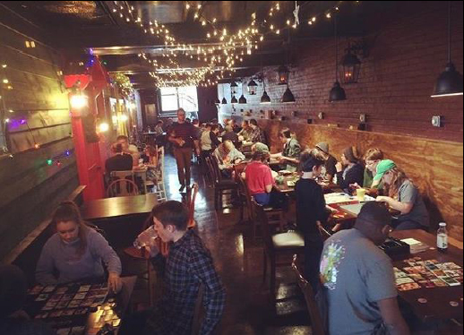

PROJECT

Rook and Pawn Cafe

LOCATION

Athens, GA

SERVICES

Architecture, Civil Engineering

DESCRIPTION

The Rook & Pawn, a uniquely designed establishment, simulates one is entering into an old London shop. AMT design team collaborated with the owner to turn a historic abandoned building into a cafe with a kitchen/food preparation area, a bar on one side, a small sitting area in front with a game shelf wall, and a back part of the cafe where the ambiance is a Victorian era alleyway.

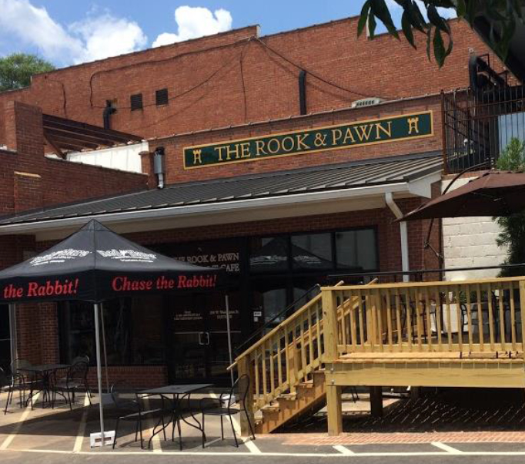
Outside is a deck to take advantage of nice weather while enjoying a game, food and drink. The project was such a successful transformation of downtown Athens that it was awarded the Athens Heritage 2016 Award for Outstanding Rehabilitation; see the “Before” photos and one can understand the accolade for the change. AMT is proud to have participated in creating an exceptional space.

CONTACT

Tim Kelly, Owner

Rook and Pawn Game Cafe

294 Washington Street, Ste 300

Athens, GA 30601

Ph: 706.543.5040; Email: rookandpawnathens@gmail.com

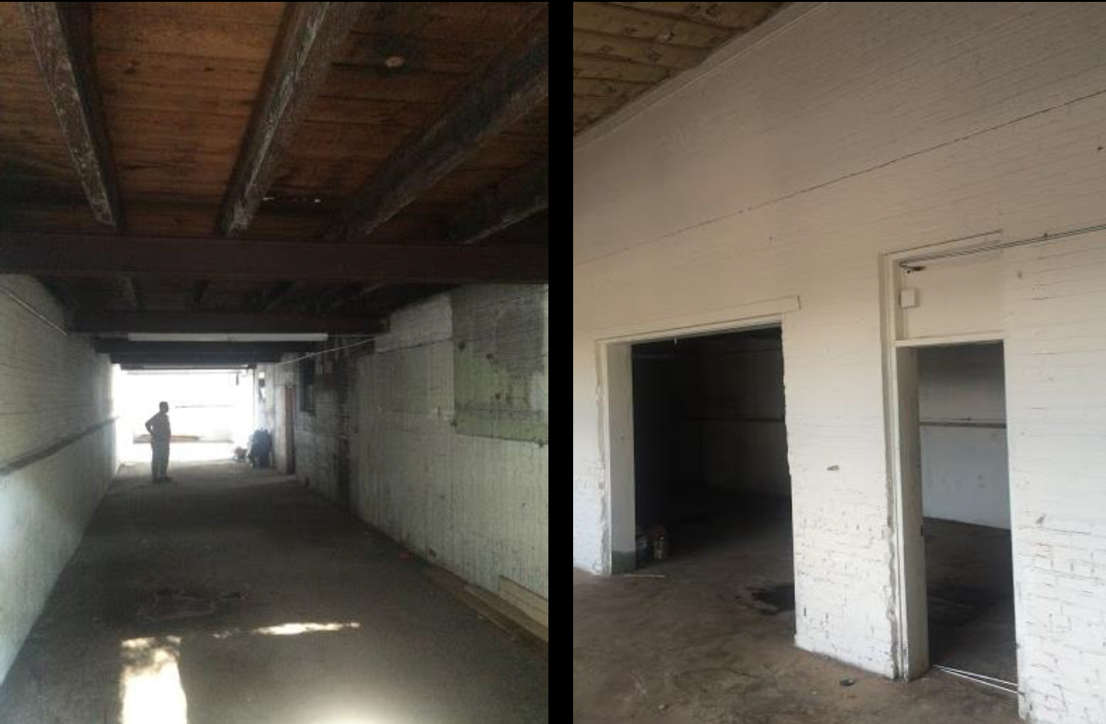
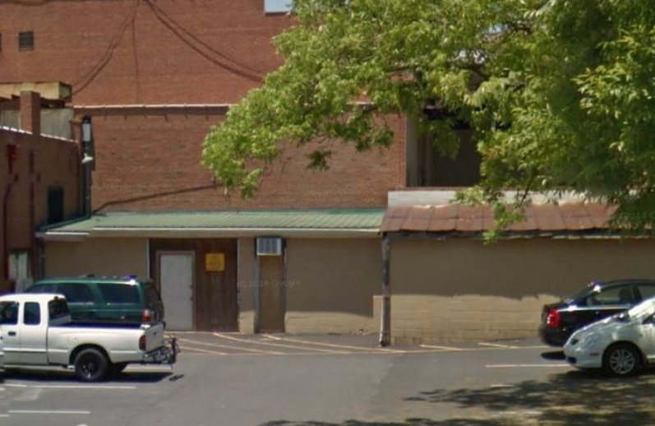
BEFORE PHOTOS

