REFERENCE Projects

____________________________________
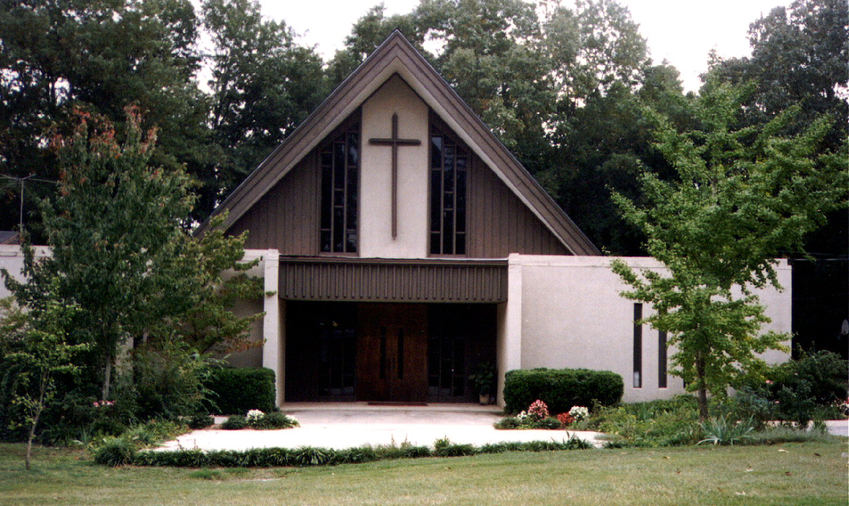
PROJECT
Covenant Presbyterian Church

LOCATION
Athens, GA

COMPLETION

SERVICES
Architecture, Civil Engineering and
Construction Management

DESCRIPTION
This 10,000 square foot addition and renovation provides space for administrative offices, classrooms and a multi-purpose assembly space for fellowship complete with a new kitchen. AMTpc developed a storm water management plan, designed an asbestos abatement program for the removal of asbestos-containing roofing material, prepared construction documents and specifications, and supervised construction. AMTpc worked closely with the owner to maintain construction costs within this budget which was approximately $700,000.

CONTACT

